- Sign in using same information you use to sign in to your computer:
2) Click on Website Administration:

3) Click on “Add or edit SCHOOL NEWS”:

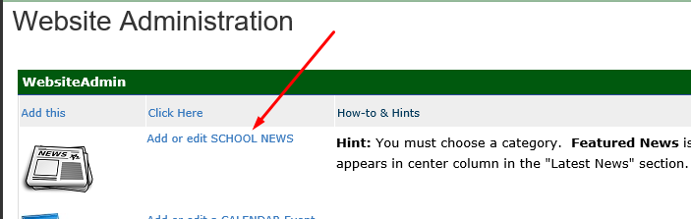

4) Click on “Create a Post”:
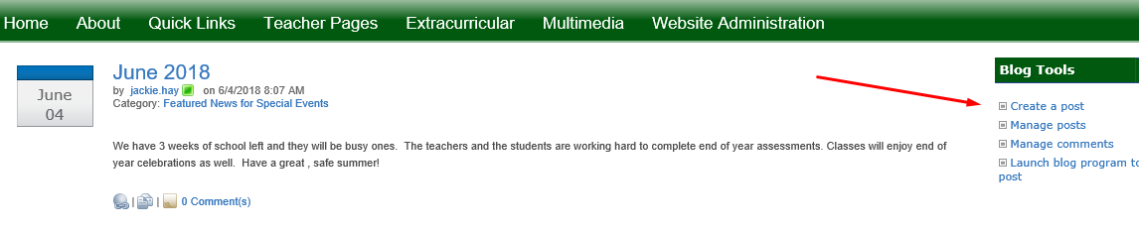

5) Type in the title, then click in the “Body” area to give you the option to click on “Insert” then “Upload File”:
6) Browse for the correct file (reminder: can only upload one at a time)
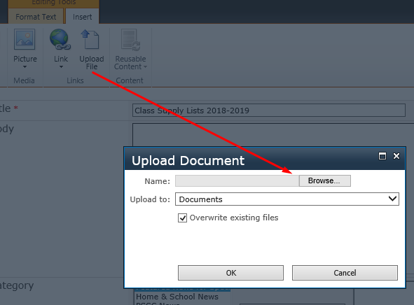

7) Select appropriate category and then SAVE:
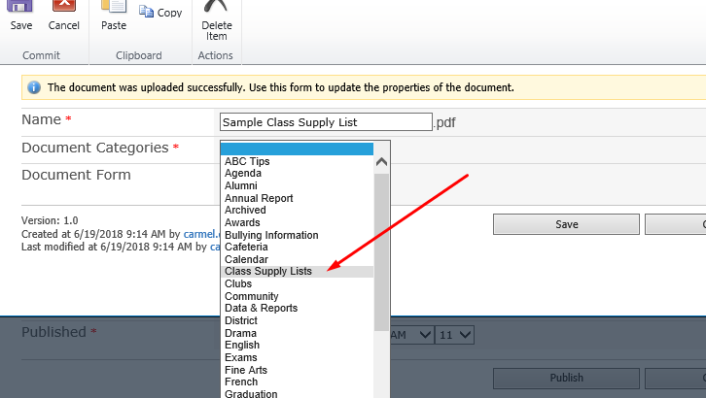

8) You will see the file in the body and then you can add more files as well: Be sure to add to School News and “Publish”
